Communication Tool for Non-Profits and disability initiatives
People and organizations who work with disability have to communicate their work in a strong way in order to be able to access opportunities for collaboration and attract wider support towards their work. This tool will ask you core questions around the identity of your organization, help you to find its unique value offering and give you an opportunity to reflect on areas for development.
Should you require, we are happy to provide further assistance and consultation services to you via telephone, email or an in-person meeting. Please contact us to arrange at FormDevConsulting@gmail.com
- Who are you?
Organization name:
Location:
Contact details:
We are a:
 | Select | Elaborate/Describe
Non Profit Organisation
Disability Project
Service Provider
Government School or entity
Social Enterprise
Voluntary Association
Corporate Entity
Design, Technology and Innovation
Other

What do you do?

- The core services we provide or the needs we wish to meet are:

- Would you categorize the programmes you provide as Health, Education, Livelihood, Social or Empowerment – or a combination of a few?

- Here is the CBR Matrix. Look at the elements from each category that you selected above. Can you select a few that applies to you? If it is something else, you may write it as well in the table provided.

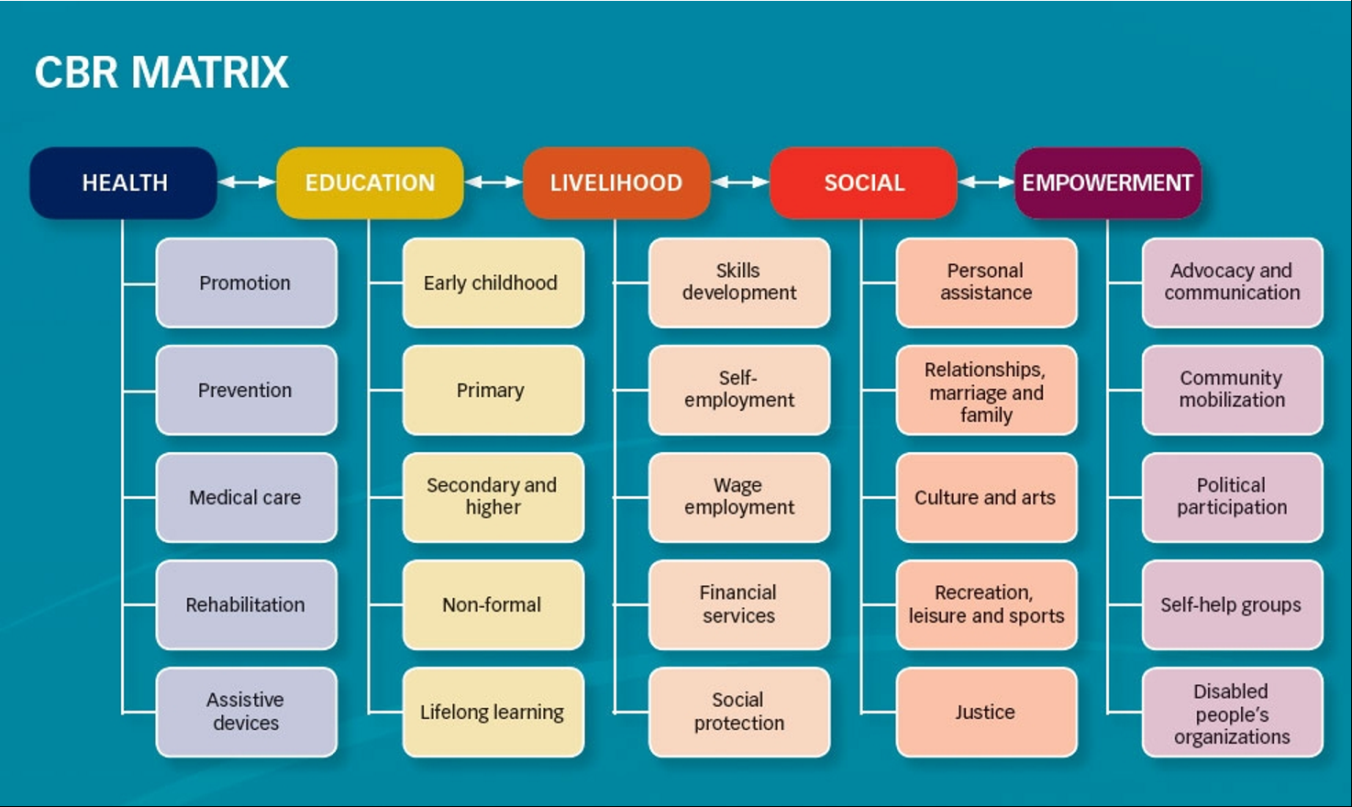

Category | Elements
1. Eg, Health | Rehabilitation, Assistive Devices
2.
3.
4.
5.

- Element Description : Describe elements as specifically as possible
Eg, Rehabilitation – Providing one 30 minute session of physiotherapy a week for 10 children

- Create a statement to put it all together. See below for examples.

Statement Examples:
Example 1:
‘We support (Health/Education/Livelihood/Social/Empowerment ) opportunities for people with disabilities by providing (select element/s) ‘ . We do this by element description
Example 2: If you are a respite care organization, like a daycare or residential facility, combine this with your core services:
We support families of people with disabilities by providing (list core services) _____________________. While doing this, we also support the (Health/Education/Livelihood/Social/Empowerment) of our beneficiaries by incorporating elements like (select element/s) . Describe the degree to which you are able to provide each element.

Your statement:
________________________________________________________________________________
________________________________________________________________________________

Who do you serve?

1. Tell us more about your beneficiaries, service users, or target market

Number of beneficiaries
Ages
Where do they come from?
Describe their social and economic backgrounds
What are their needs?

2. Do you have specific information on the types of disability and the degree of disability that you work with?

Number of People | Type of Disability or Diagnosis | Degree of Disability *

*The Degree of disability is usually classified by rehabilitation therapists, eg Physiotherapists, Occupational Therapists and Speech therapists, who use a variety of researched tools and classification systems to do this. It is a useful way to understand the type of care, support and rehabilitation services required. Sometimes they can also be used as outcome measures to measure the impact of rehabilitation services.

How do you do it?

- How do you measure change created from your work?

- If you have not done this so far, do you have some ideas on how you might do it in the future?

- What means do you use for generating income?

Type of Income: | % of total funding
Fee for services
Government funding
Grant/Donor Funded
Not funded/Self funded
Other:

- Does your current funding structure help you to meet all your desired objectives? If no, describe

- Do you feel comfortable about the sustainability of your work or organization in the short, medium and long term?

- Social capital:

Read each statement, and rate if applicable to you
 | Very Satisfied | Partly satisfied | Not Satisfied
Our organization has a board and management structure that is engaged, skilled and reliable.

We have rehabilitation therapists informing the overall design and strategy of our programmes

We have a strong volunteer base that contributes to our work in a useful way

Our beneficiaries and their families support and advocate for our organization

We are able to achieve a strong level of engagement with our work through the internet and social media

Our stakeholders (government, donors, community and volunteers) are very responsive to our needs

We feel that we are supported to develop our work

- What would you describe to be the biggest strength of your organization?

Why do you do it?

This section will help you to tell your story and define the unique value that your work provides or will provide to society in the future. You can also build strong marketing and communication messages from information that arises here.

- Your History - At the start of any organization is a story. Why was it started? Was it a specific event, story or set of circumstances?

- Are you the only organization to that does this kind of work in your region/ area?

- Do you approach your work in a way that is stronger, more unique or innovative than others?

- Some of the things our beneficiaries, or the families of our beneficiaries say or feel about our work is:

- We also know we are making a positive change because:

- Our impact measurement processes show us that:

- What are the core values that you hold around your work?

PUT IT TOGETHER!
We hope that this tool has been useful and that the questions have brought out a lot of important information. The next step is to review it - print it out, spend some time looking at it and discuss it with others if you need to. What stands out for you? What are the gaps? Where are the areas for development?

Based on this tool, our main areas for growth are:
1.
2.
3.
4.
5.

We hope that this process has been of assistance to you!
We would love to hear feedback on it- please email us if you have any suggestions.
We are also happy to provide you with a review of your answers and provide further consultation services to your organization as required. For more information on our rates and services, please contact us at FormDevConsulting@gmail.com.

